**HOW TO INSTALL REACT APP? (\*)Windows version**

There are 2 main steps.

I. Install Nodejs (If you have Nodejs already, skip this step)

II. Install React

(\*)React run on Nodejs that why we need to install Nodejs before React.

1. INSTALL NODEJS
2. Go to Nodejs official website: <https://nodejs.org/en/>

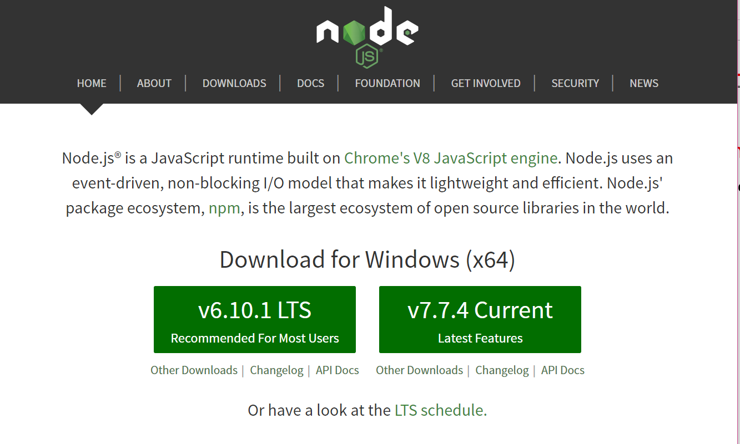

1. Download: Choose the version 6.10.1 LTS (Recommend for Most Users)

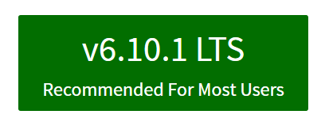

1. Save it

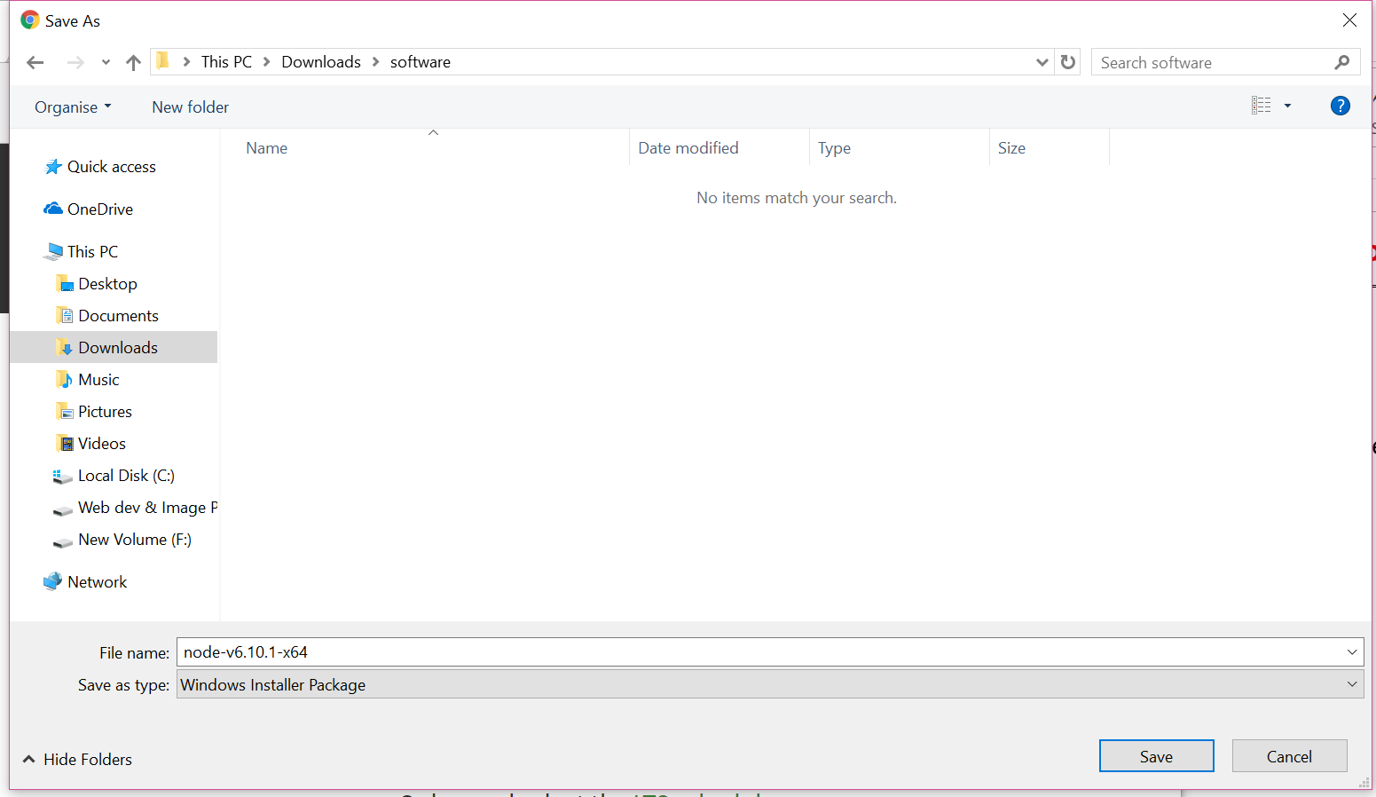

1. Installation
2. +Next

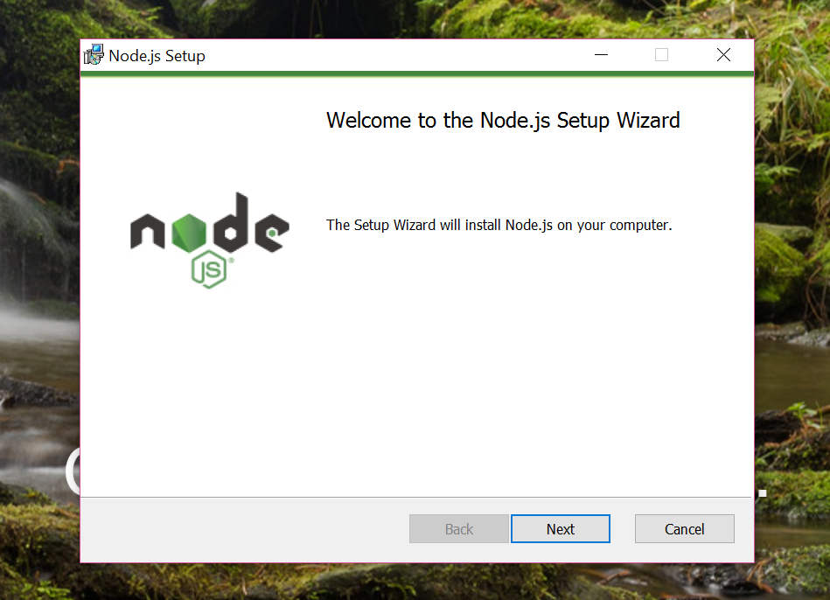

1. +Stick the check box. “I accept the terms in the License Agreement”

+Click Next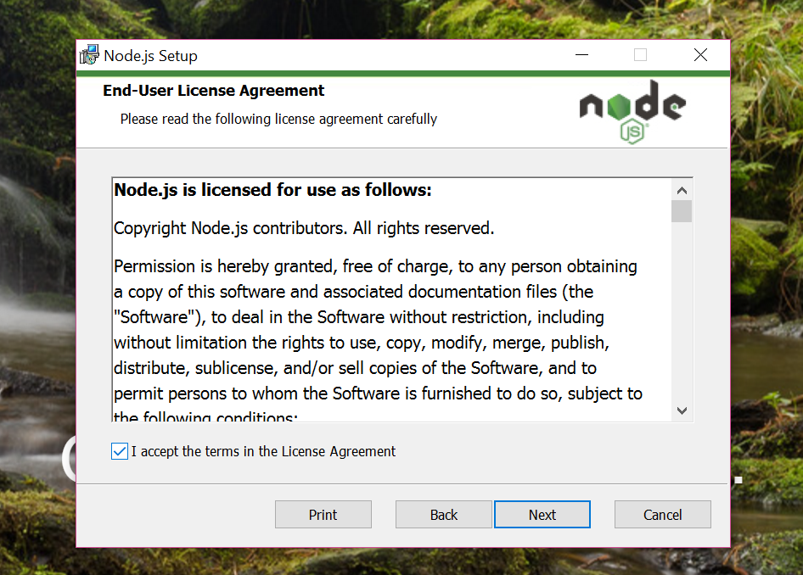

1. +Choose the location of installation

+Click Next

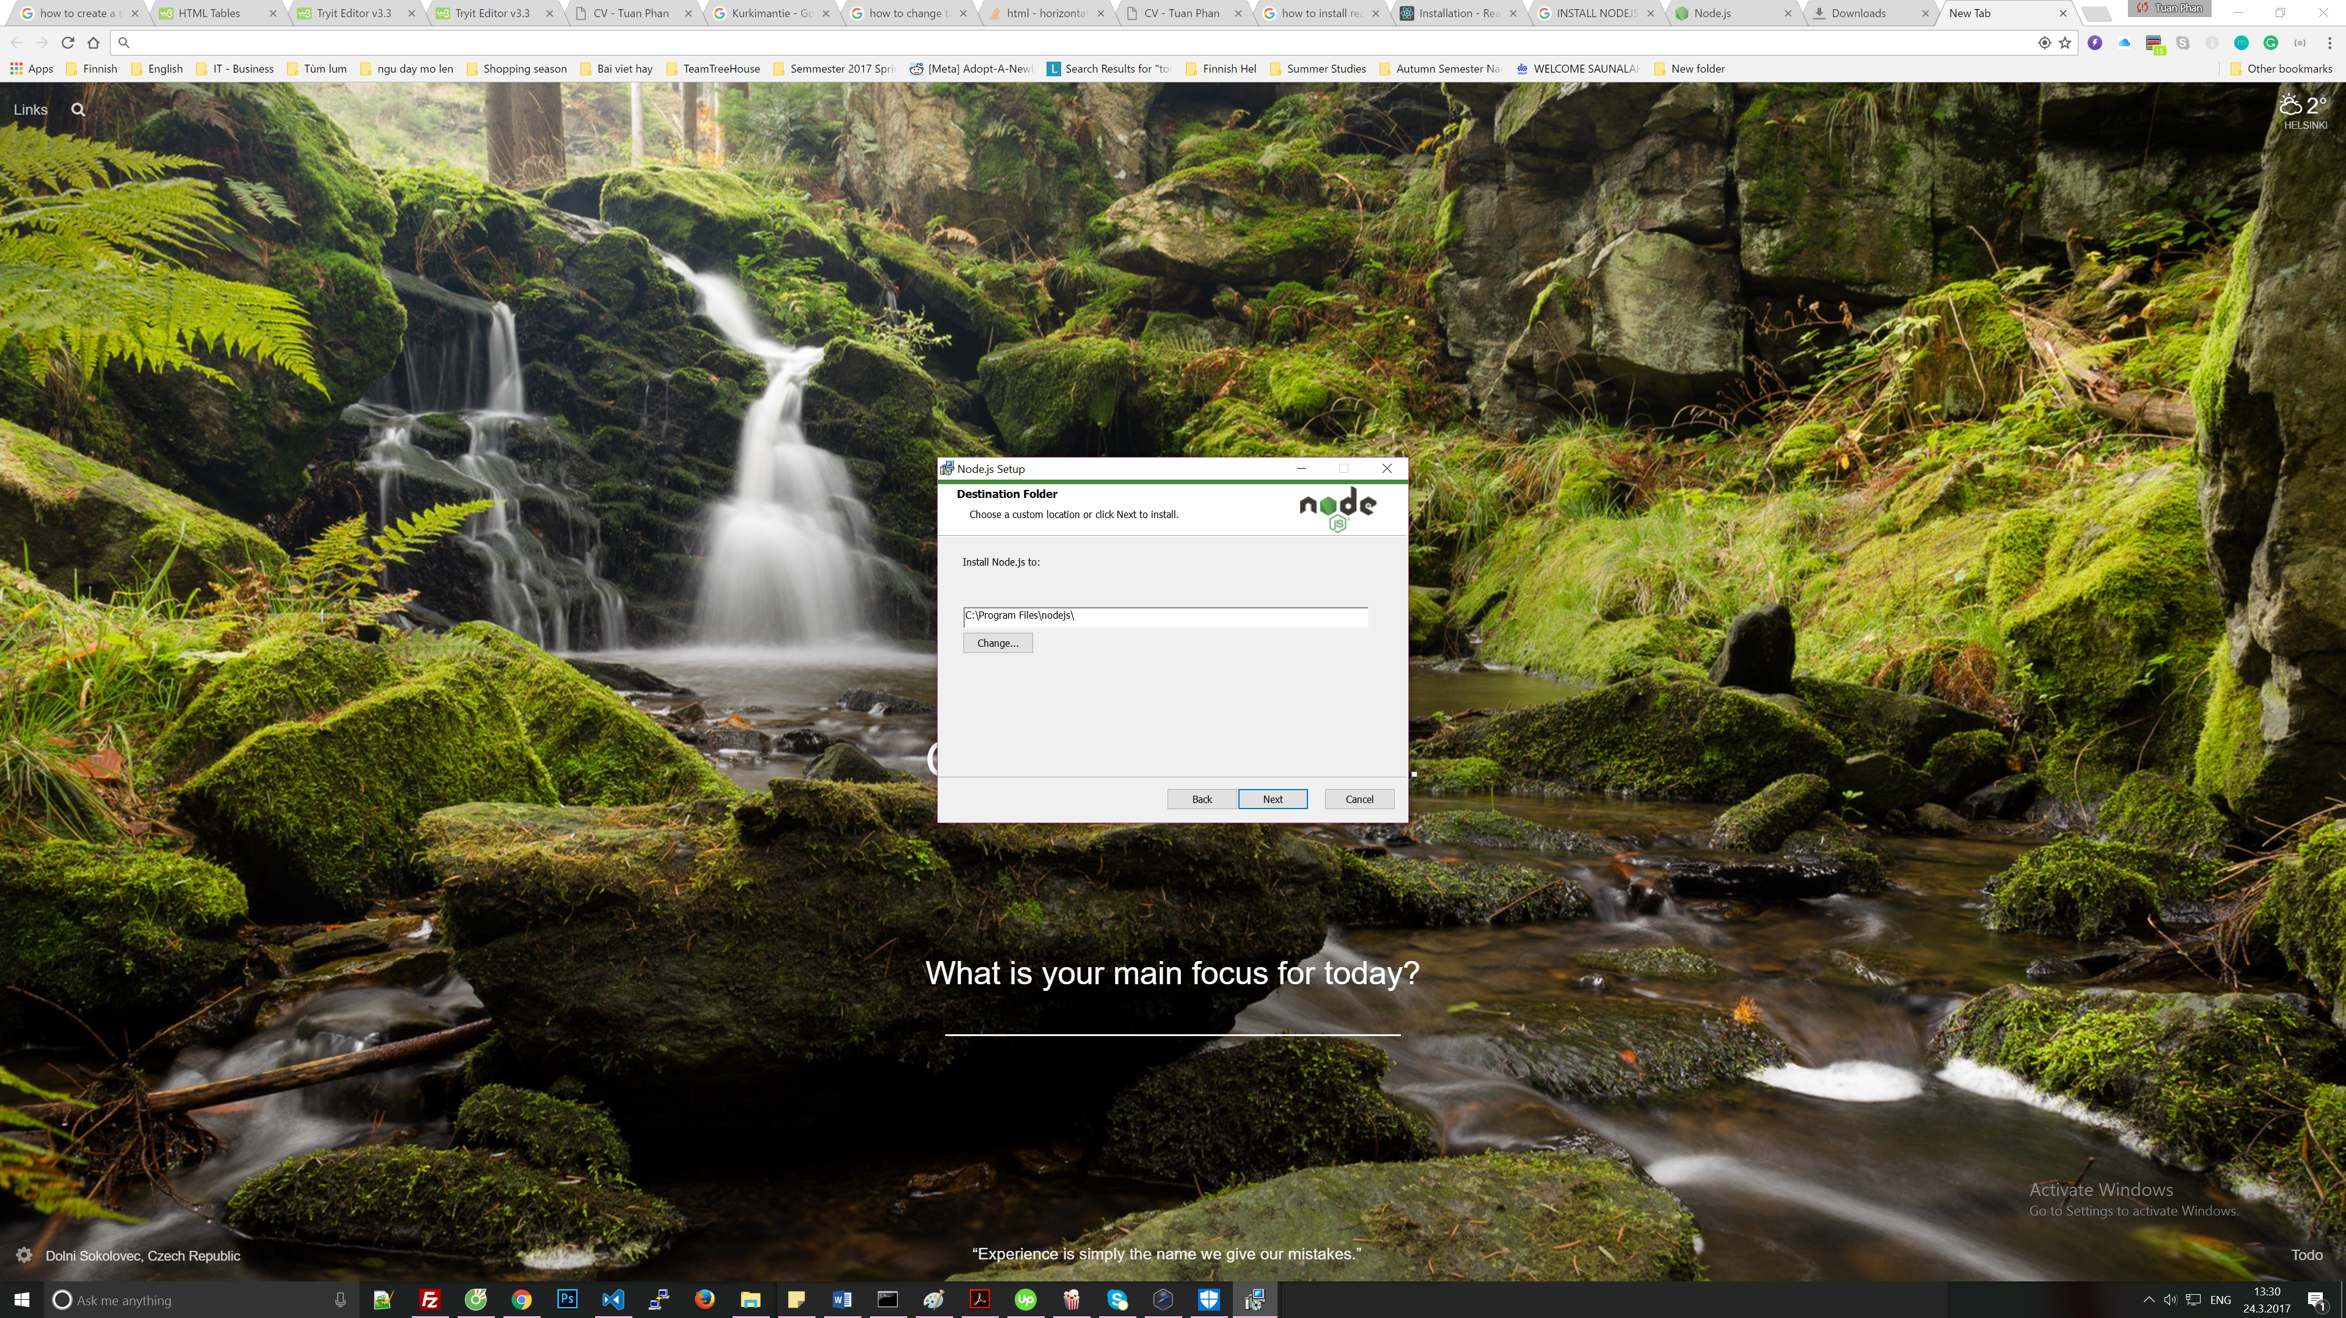

1. +Click Next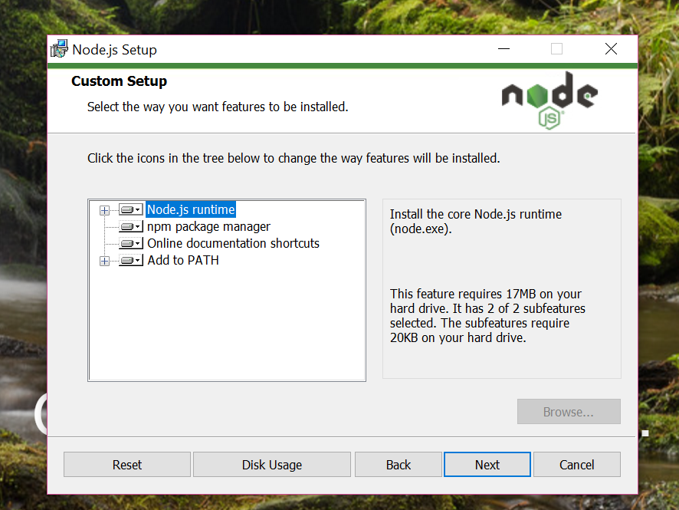
2. +Click Install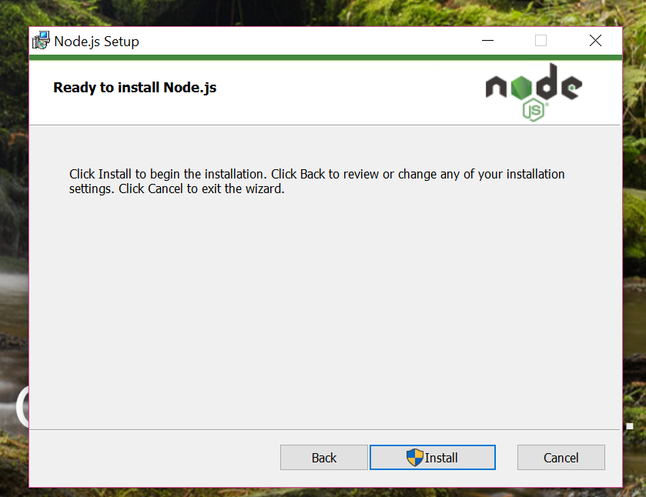
3. Wait a minute

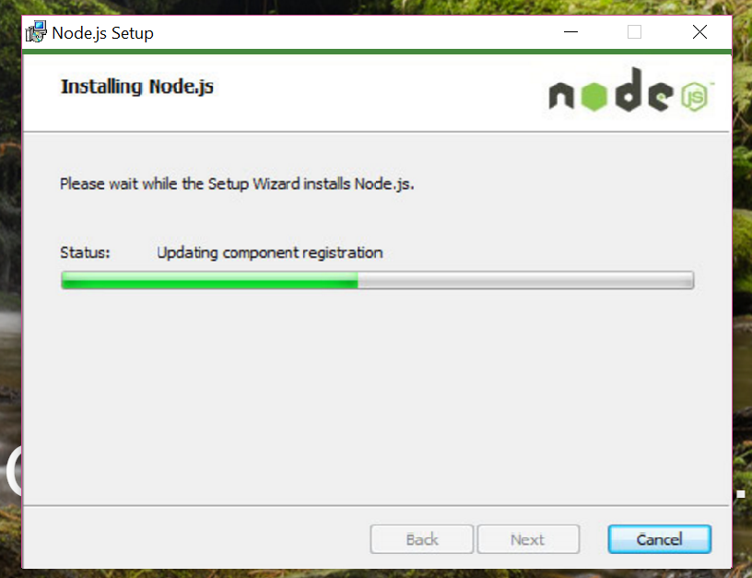

1. Finnish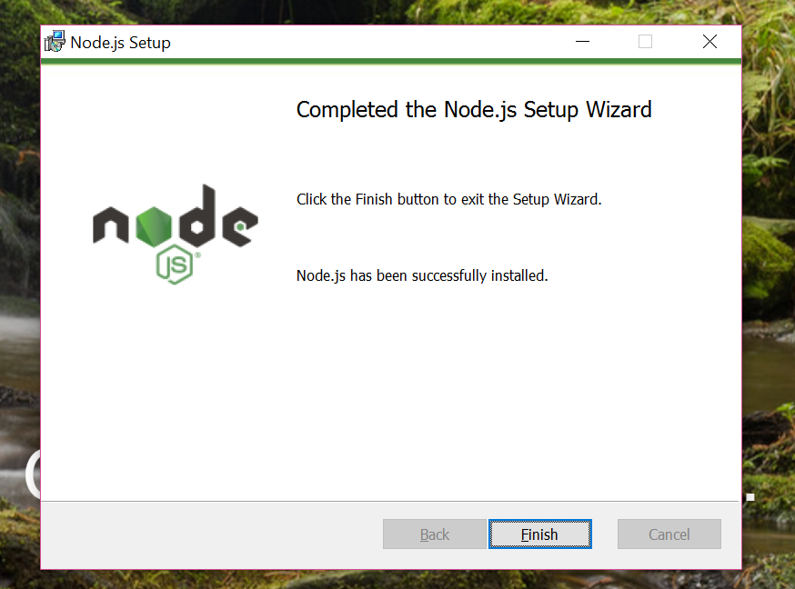
2. INSTALL REACT

If you have installed Nodejs already. Let’s go to these steps.

1. Go to React official website <https://facebook.github.io/react/>

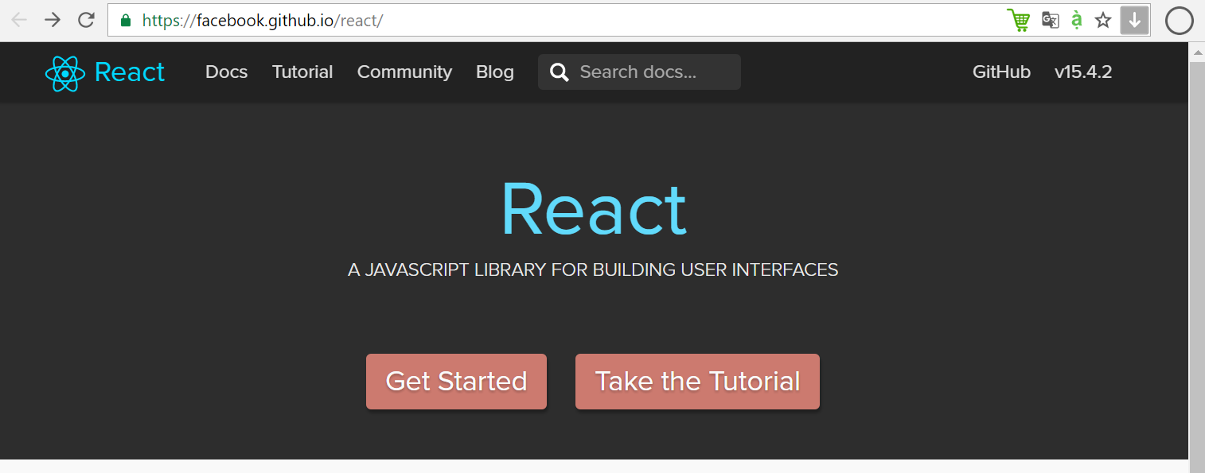

1. Click button 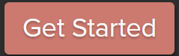
2. In the new page, click Installation

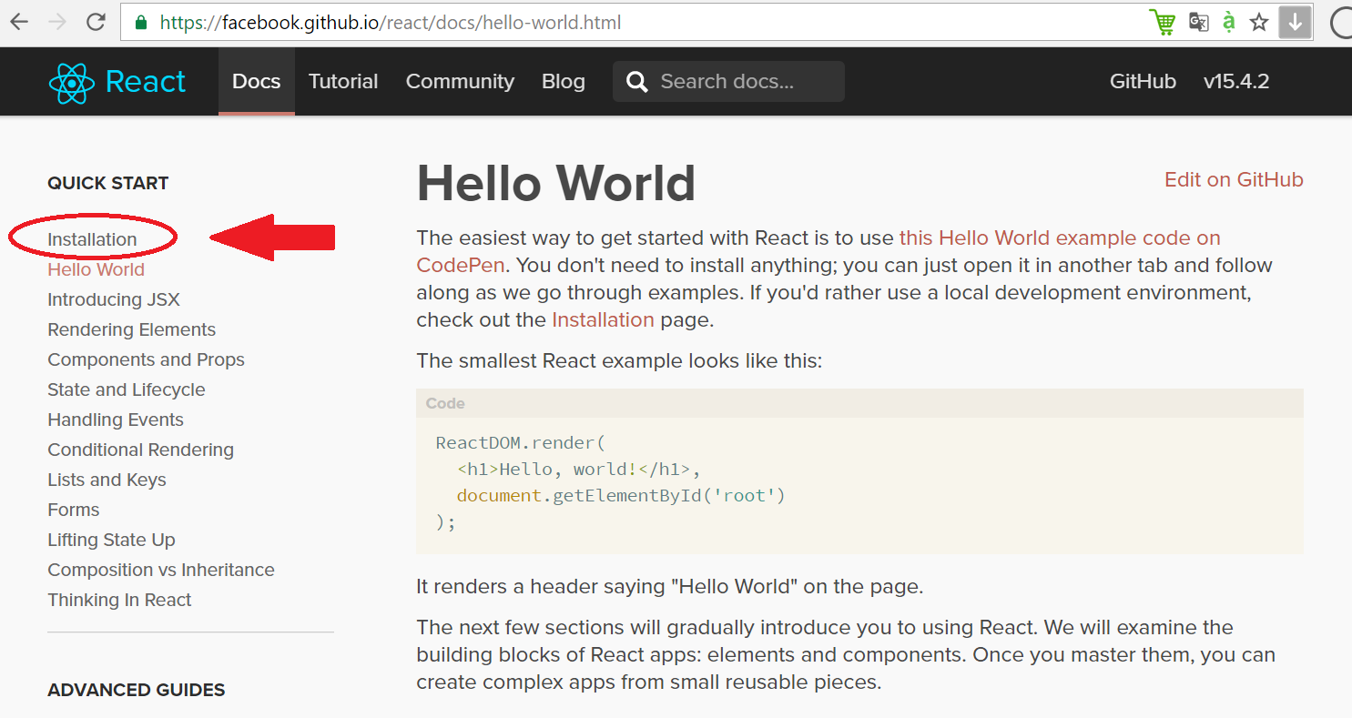

1. Follow the code in the box to install your first React App(\*)

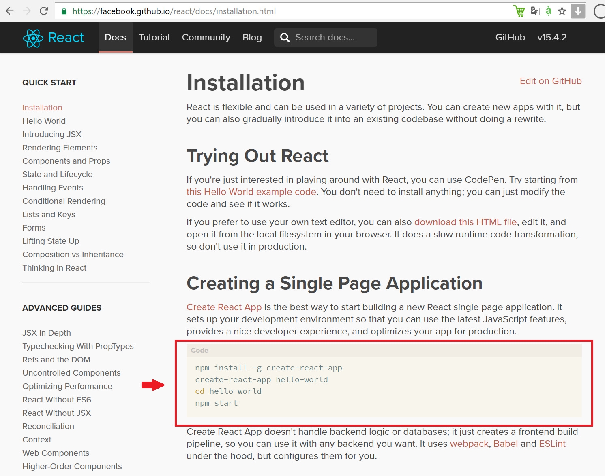

(\*)If you are not used to Nodejs, follow these below steps.

a) Press: “Windows + R” to open Run dialog box

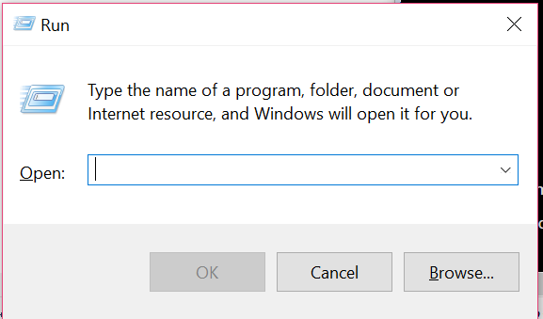

b) Type “cmd” then press Enter

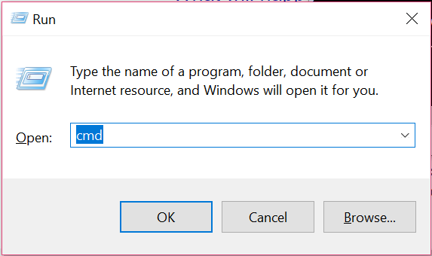

1. Type “cd desktop”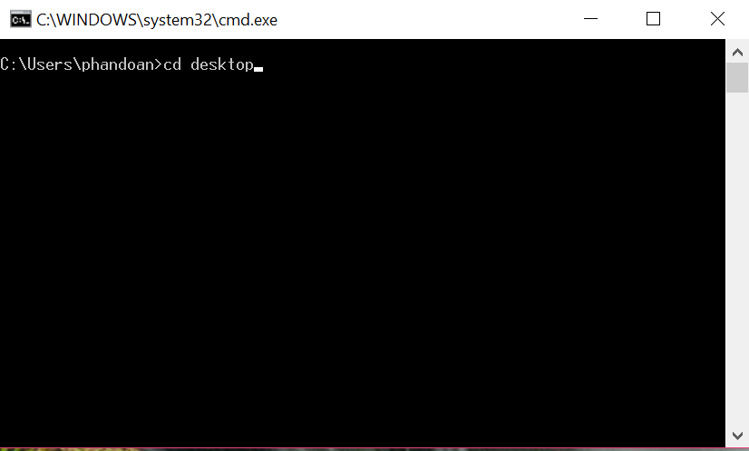
2. Type “npm install -g create-react-app” to install React App

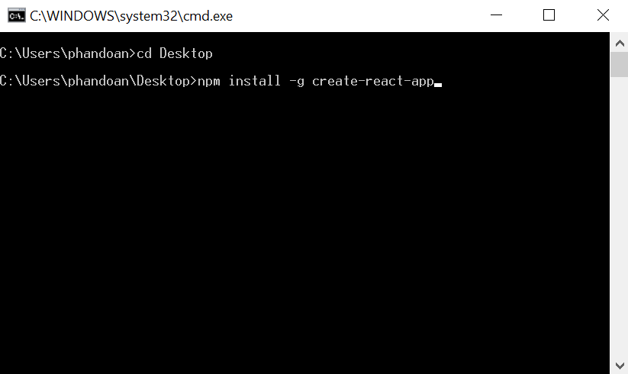

It is going take about 1 minute to finish

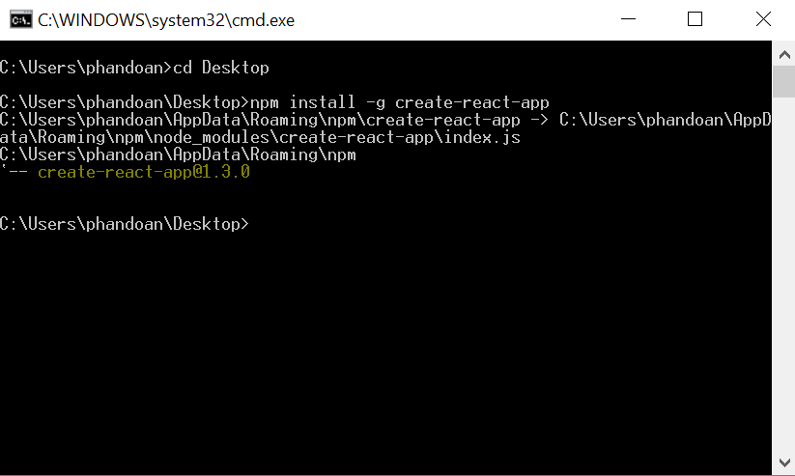

1. Type “create-react-app my-react-app” (\*).

+You can replace my-react-app by whatever(\*\*) for your app’s name.

+For example: I named my app: react-beginer

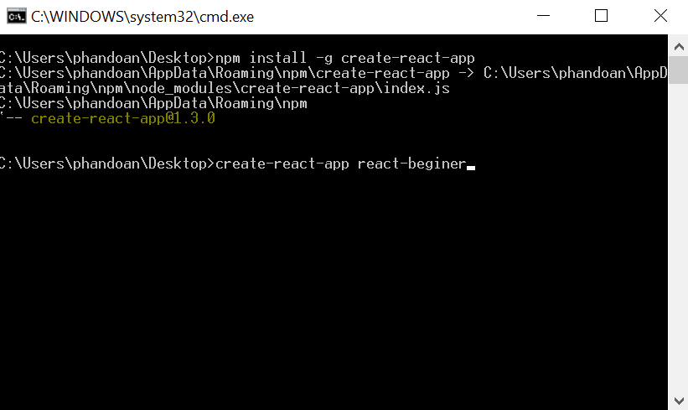

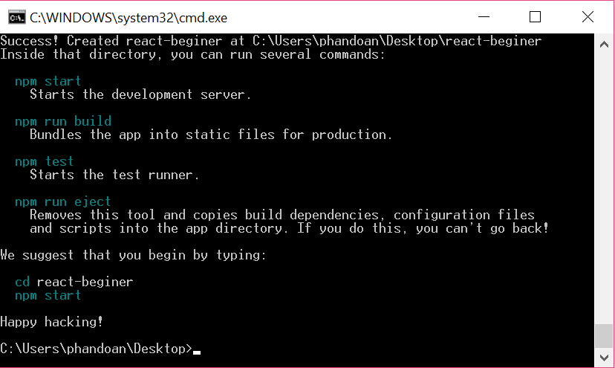

Installation is successful.

1. Last step.

Go to your app folder by using command:

“cd my-react-app”

Cause of my name app is “react-beginer”

I will replace my-react-app by react-beginer

“cd react-beginer”

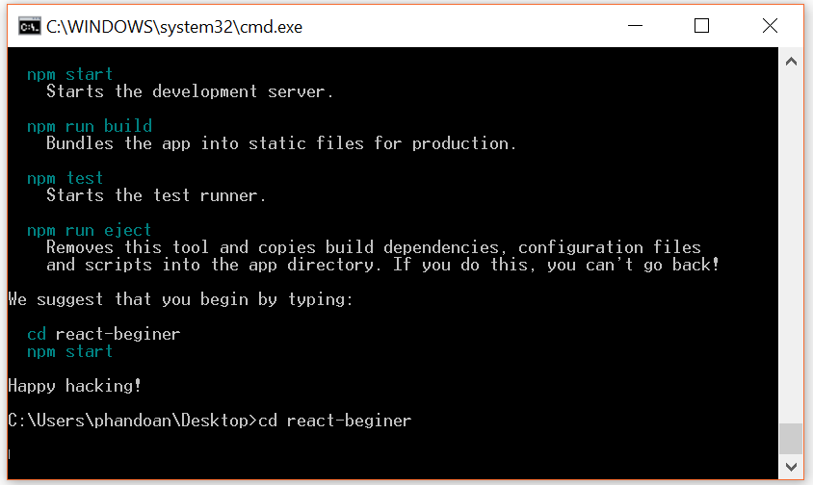

Type “npm start”

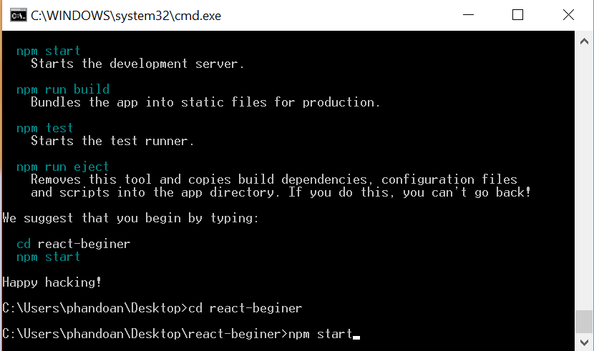

Wait for a while.

And after it notices “Complied successfully” like the window below.

+Go to <http://locahost:300/> to check your app.

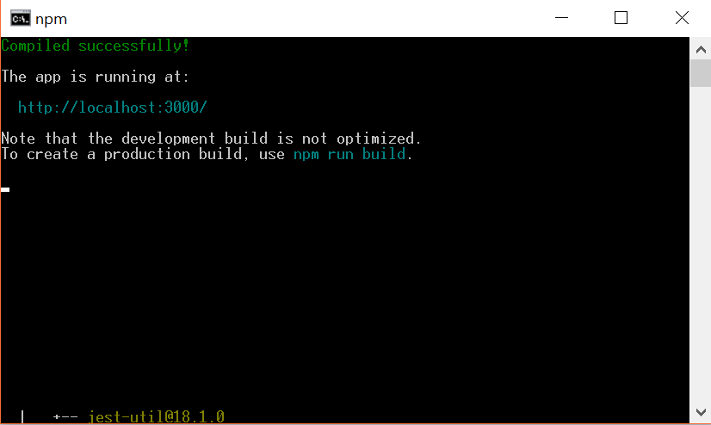

If you see something like this

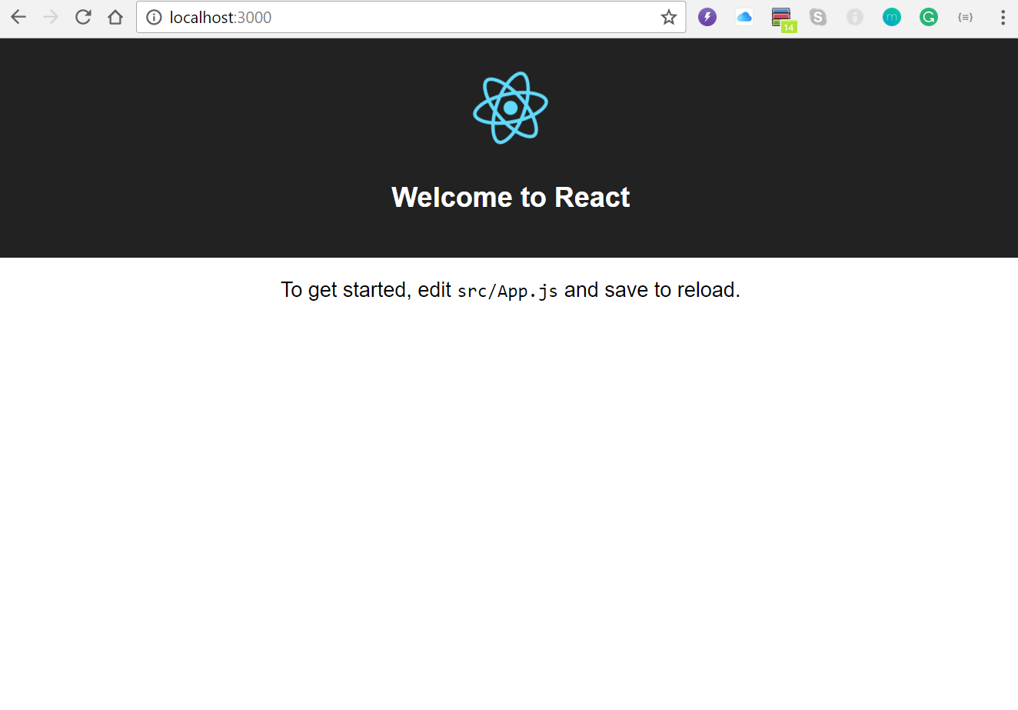

Congratulation!

Now open your IDE and create your own ReactApp.